**Hong Kong Institute of Vocational Education**

**Department of Information and Communications Technology**

**EA Project**

**ITP4506**

**System Documentation**

**Legend Motor Limited**

**vehicles and insurance System**

**Group Members**

|  |  |  |  |
| --- | --- | --- | --- |
| **Student ID** | **Name** | **Contribution** | **Signature** |
| **230138439** | **Sham Hoi Kin** | **60%** | **Ronald** |
| **230274972** | **Chan Tsz Ho** | **40%** | **Marco** |

Content Page

1 Driving Question 3

2 User Analysis 5

2.1 User Characteristics 5

2.2 Techniques for observing and listening to users 6

2.3 Environmental Analysis 7

2.4 Recruiting Users 7

2.5 Task Analysis (HTA) 7

3 Web Design Concepts 10

3.1 Metal Model 10

3.2 Affordance 11

3.3 Content Organization 12

3.4 Visual Organization 13

3.5 Navigation Design 16

## Driving Question

How does good HCI design help Legend Motor vehicle system improve user satisfaction, and what advantages does it bring in this regard? (250 words)

A good HCI design can help the Legend Motor vehicle system improve user satisfaction.

Firstly, Usability and utility is one of the primary concerns in HCI design goals. It can be enhanced through well-organized interfaces. Clear navigation and recognizable icons help users quickly access necessary functions, reducing cognitive load. For example, every pages have navigate bar on top of the website to navigate user to different pages according to their willingness to view or interact with.

Secondly, Effectiveness can ensure the tasks to be completed accurately and successfully, minimizing errors and maximizing user satisfaction through streamlined processes. In the system, it has to display the best input button for users to click or input field to type for user.

Thirdly, Efficiency can optimize workflows to reduce the time and effort required to perform tasks, allowing users to achieve their goals swiftly and with minimal friction. In the Get a Quote section, User have to easily and quickly to get a quote by inputting the must-need information.

Fourth, Safety can protect user from potential hazards, ensuring a secure interaction with technology. In the payment method, User can only choose one method which ensuring the user won’t access multiple ways. A better and easy to protect users’ personal information.

Lastly, the appeal enhance the aesthetic design and emotional engagement, making the systems visually pleasing and enjoyable to interact with. On the website, there are multiple attributes that have animations and interactions with users to experience.

## User Analysis

## User Characteristics

1. Learning Style

* Users might prefer diagrams, charts and visual interfaces to understand information.

1. Tool Preferences

* Users prefer mobile apps and web-based platforms. And self-service tools.
* Admins may prefer desktop applications with dashboards for managing inquiries and sales processes.

1. Physical differences

* Older users might require larger text and simplified interfaces.

1. Cultural differences

* Users may prefer content in their native language. necessitating multilingual support.

1. Knowledge of job

* Users require levels of understanding about vehicle purchasing and insurance processes.
* Admins have to be experienced staff with the systems and customers’ interactions.

1. Application familiarity

* Users might be familiar with online purchasing platforms; some may need guidance.
* Admins have to be familiar with CRM systems.

1. Primary and secondary users

* Primary Users:
  + Vehicle Sales Personnel: Actively use the system to manage customer inquiries, sales processes, and vehicle information.
  + Insurance Sales Personnel: Use the platform to generate quotes, communicate with customers, and manage insurance policies.
* Secondary Users:
  + Customers: Individuals purchasing vehicles and insurance who rely on primary users for assistance and information.

## Techniques for observing and listening to users

1. Think Aloud: Users express their thoughts, feelings, and decision-making processes while interacting with the system.
2. Talk Right After: Users are asked to provide feedback immediately after completing a task or interaction with the system.
3. Role Playing: Users are asked to take on specific roles or scenarios while interacting with the system, simulating real-life situations.
4. Cueing Recall with Videotape: Users interact with the system while being recorded on video, which is later reviewed to cue recall.
5. Focus Groups: A moderated discussion with a group of users who provide feedback on their experiences, needs, and suggestions for the system.
6. Mailed/Online Surveys: Structured questionnaires are distributed to users to gather quantitative and qualitative data about their experiences and preferences.

## Environmental Analysis

Users use our interface through Digital Environment. It evaluates the current online presence, including website usability. Ensure fast loading times and intuitive navigation.

## Recruiting Users

Recruiting participants for user analysis should target the user groups that ensure a mix of demographics to represent the customer base accurately.

In incentives, we can offer incentives such as discounts on services or gift cards to encourage participants in surveys, interviews and usability test.

Also, we can collaborate with local automotive and insurance communities to recruit participants.

## Task Analysis (HTA)

The main task users are trying to achieve. For instance, in the context of Legend Motor Limited, the primary task could be "Purchase a Vehicle Online" or "Request an Insurance Quote."

* Purchase a Vehicle Online

1. In order to Purchase a Vehicle Online
2. Browse Available Vehicle
   1. Access Vehicle Listing Page
   2. Use Filters
   3. Sort Results
   4. View Thumbnails
3. Select a Vehicle
   1. Click on Vehicle Thumbnail
   2. Review Specifications
   3. Check Available Options
4. Customize Vehicle Options
   1. Choose Color and Trim
   2. Select Additional Features
   3. Add Accessories
5. Review Purchase Details
   1. Confirm Selections
   2. View Price Breakdown
   3. Read Terms and Conditions
6. Submit Purchase Request
   1. Enter Personal Information
   2. Provide Payment Information
   3. Review and Confirm Order
   4. Receive Confirmation

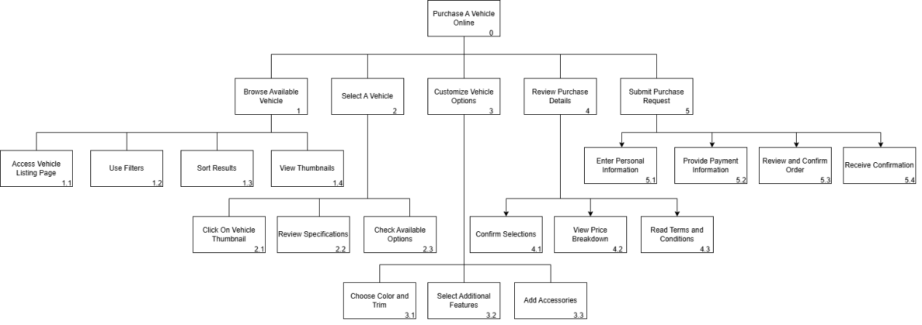

Plan 0:

do 1-2-3-4-5

* Request an Insurance Quote

1. In order to request an insurance quote
2. Access Quote Request Feature
   1. Navigate to Insurance Section
   2. Select an insurance coverage option
3. Provide Personal Information
   1. Input name, email
   2. Input vehicle model and year
4. Input Coverage Preferences
   1. pick policies and payment methods
   2. input price, age, experience
   3. input driving offence point and occupation
5. Review and Submit Quote Request
   1. Review Information
   2. Confirm Terms and Conditions
   3. Submit Request

plan 0:

do 1-2-3-4

## Web Design Concepts

## Metal Model

To employ this principle, the design reflects common practices in all pages. The header of the page is common to other famous pages. for example, the login navigation is always on the top right corner of the page.

Also, we are using terminology like “Add to application”, “Continue” to help users navigate the site intuitively.

And some familiar icons like a back icon to navigate the site.

## Affordance

Our website has varied properties of an object that are functionality. For example, our website has almost all the buttons to look clickable using shadows, highlights or boarder to mark out.

In the meantime, our website has links that are also easily accessible and identifiable for users.

## Content Organization

We have designed our website to be content organized involves structured information which is logical and easy for users to navigate. For example, our website are clear categories and subcategories for vehicles purchasing and insurance quoting.

We group related things, forming groups in terms of the way users think. And give names to different groups.

We are using Ambiguous Organizational scheme to organize items, and the bottom are using topical and task-oriented to categorize.

A well-organized menu with clear labels. For example, In the index page, its only show the company’s stuff.

After you go to the insurance page, it only shows the insurance things.

## Visual Organization

Our website is designed to help users navigate content easily and understand relationships between different elements. For example, in Proximity, we place related content close together to visually indicate their relationship.

We also group items using alignment along a common edge or axis. Proper alignment creates a visual connection between elements and enhances the overall structure of the layout.

Our website is also consistent which ensures that similar elements across the site share the same visual styles, behaviors and layout.

In the meantime, we also make the items on our website look different using contrast. By making items different, it helps users to pick out organization.

## Navigation Design

Effective Navigational Design is for creating a user-friendly web platform. Ensure that users can easily find the information they need and navigate through various sections seamlessly.

For example, in Hierarchical Navigation. Information is organized in a parent-child relationship.

Under “Insurance Coverage Options”…

And we have Database Navigation using search engines that allow users to enter specific content or products quickly to catch different cars to purchase.

Also we have Breadcrumbs to show users how they got there.